**Batch: D - 1 Roll No.: 16010122096**

**Experiment / assignment / tutorial No. 02**

**Grade: AA / AB / BB / BC / CC / CD /DD**

**Signature of the Staff In-charge with date**

|  |
| --- |
| **TITLE: Project Metric estimations for Mini Project** |

**AIM:** To enable the students learn different techniques for performing software size and cost estimation

**______________________________________________________________________**

**Expected Course outcome of Experiment:**

**CO 1:** Understand the software development process and Estimate different types of resources for the given project.

**_____________________________________________________________________**

**Books/ Journals/ Websites referred:**

1. Roger Pressman, “Software Engineering”, sixth edition, Tata McGraw Hill.
2. <http://sunset.usc.edu/csse/research/COCOMOII/cocomo_main.html>
3. <http://sunset.usc.edu/research/COCOMOII/expert_cocomo/expert_cocomo2000.html>
4. <https://w3.cs.jmu.edu/bernstdh/web/common/webapps/oop/fpcalculator/FunctionPointCalculator.html>

**_____________________________________________________________________**

**Pre Lab/ Prior Concepts:**

Software projects have tendency of going past their deadline, going over budget, or both. The problem lies in the estimation of the amount of effort required for the development of a project. The cost estimation is usually dependent upon the size estimate of the project, which may use lines of code or function points as metrics. There are several different techniques for performing software cost estimation, including expert judgement and algorithmic models. Estimation by expert judgement is a common way of estimating the effort required for a project. Unfortunately, this method of estimation does not emphasize re-estimation during the project life cycle, which is an important part of project tracking, because it allows the estimates to be improved during the project life cycle. The quality of a cost estimation model is not so much attributed to the initial estimate, but rather the speed at which the estimates converges to the actual cost of the project. COCOMO is a popular algorithmic model for cost estimation whose cost factors can be tailored to the individual development environment, which is important for the accuracy of the cost estimates. More than one method of cost estimation should be done so that there is some comparison available for the estimates. This is especially important for unique projects. Cost estimation must be done more diligently throughout the project life cycle so that in the future there are fewer surprises and unforseen delays in the release of a product.

**Estimation of size and cost of the developing project is required for the following major decision situations**

* Financial decisions involving a software development effort
* Setting project budgets and schedules as a basis for planning and control
* Deciding on or negotiating tradeoffs among software cost, schedule, functionality, performance or quality factors
* Making software cost and schedule risk management decisions
* Deciding which parts of a software system to develop, reuse, lease, or purchase
* Making legacy software inventory decisions: what parts to modify, phase out, outsource, etc
* Deciding how to implement a process improvement strategy, such as that provided in the SEI CMM

Defining Cost estimation:

Cost estimation can be defined as the approximate judgement of the costs for a project. Cost estimation will never be an exact science because there are too many variables involved in the calculation for a cost estimate, such as human, technical, environmental, and political. Futhermore, any process that involves a significant human factor can never be exact because humans are far too complex to be entirely predictable. Furthermore, software development for any fair-sized project will inevitably include a number of tasks that have complexities that are difficult to judge because of the complexity of software systems.

Cost estimation is usually measured in terms of effort. The most common metric used is person months or years (or man months or years). The effort is the amount of time for one person to work for a certain period of time. It is important that the specific characteristics of the development environment are taking into account when comparing the effort of two or more projects because no two development environments are the same. A clear example of differences in development environments are the amount of time people work in different countries; the typical workweek in North America is 40 hours per week, while in Europe the typical workweek is 35 hours per week. Thus, when comparing a project from North America with a project from Europe, a conversion factor would have to be used to all for an accurate comparison. Different variables can be used for cost estimation, which leads to a difficulty when comparing projects if standard models or tools are not used. For example, a cost estimate can include factors from management, development (e.g., training, quality assurance), and other areas specific to an organization.

Estimator:

The people who do the cost estimates could be either directly or indirectly responsible for the implementation for a project, such as a developer or manager, respectively. Someone who has knowledge of the organization and previous projects could use an analogy-based approach to compare the current project with previous projects, which is a common method of estimation for small organizations and small projects. The historical data is often limited to the memory of the estimator. In this case, the estimator would need to be experienced and would likely have been with the company for awhile.

Some people believe it is better if the estimates are done by outsiders so that there is less chance of bias. It is true that people outside an organization will likely have to deal with fewer company politics than people within the organization. For example, the developer for a company may want to please the manager and so give an estimate that is overly-optimistic. The disadvantage of having an outside estimate is that the person would have less knowledge of the development environment, especially if the person is from outside the company. An empirical method of estimation would then be required, such as the Constructive Cost Model (COCOMO. Empirical methods of estimation can be used by all types of estimators. There may be some resistance to using an empirical method of estimation because there may be some question on whether a model could outperform an expert. People who are accurate estimators are rare in our experience, and so it is best to get the opinion of several people or tools.

**Cost estimation using different COCOMO models:**

**FP:**

**MANUAL CALCULATIONS:**

|  |  |  |  |  |  |
| --- | --- | --- | --- | --- | --- |
| **Measurement Parameter** | **Count** | **Simple** | **Average** | **Complex** | **Total** |
| **External Inputs** | 5 | 4 | 6 | 9 | 31 |
| **External Outputs** | 4 | 5 | 7 | 10 | 28 |
| **External Inquiries** | 3 | 2 | 3 | 5 | 8 |
| **Internal Logical Files** | 5 | 8 | 11 | 14 | 57 |
| **External Interface Files** | 1 | 3 | 6 | 8 | 5 |
| **Count Total** |  |  |  |  | **129** |

**Factors and their values:**  
  
Each factor is usually rated on a scale of 0 to 5, where:

**0** = No influence, **1** = Incidental, **2** = Moderate, **3** = Average, **4** = Significant,

**5** = Essential

|  |  |  |
| --- | --- | --- |
|  | **Factor** | **Value** |
| **1** | Backup and Recovery | **4** |
| **2** | Data Communication | **2** |
| **3** | Distributed Processing | **0** |
| **4** | Performance Critical | **4** |
| **5** | Existing Operating Environment | **3** |
| **6** | On-Line Data Entry | **5** |
| **7** | Input Transactions Over Multiple Screens | **3** |
| **8** | Master File Updated On-Line | **4** |
| **9** | Information Domain Values Complex | **3** |
| **10** | Internal Processing Complex | **3** |
| **11** | Code Redesigned for Reuse | **4** |
| **12** | Conversion / Installation in Design | **2** |
| **13** | Multiple Installations | **3** |
| **14** | Application Designed for Change | **4** |

**Calculate Total FP**:

Count total × (0.65 + 0.01 × ∑F) = 129 × (0.65 + 0.01 × 44)

Total FP = 129 × (0.65 + 0.44) = 120 × 1.09 = 130.80 ≈ 131

**Person-Months Required**:

Using a realistic productivity rate 4 FP per person-month:

Persons per month = 131 / 4 = 33 persons / month

**Total Cost in INR**:

Assuming a cost per FP of ₹7,000:

Total Cost in INR = 131 × 70,000 = ₹9,17,000

### 

### Final Estimate:

The FP estimate for this project is 131.

The project is estimated to require 33 persons per month.

The total cost is approximately ₹9,17,000.

**ONLINE CALCULATIONS:**

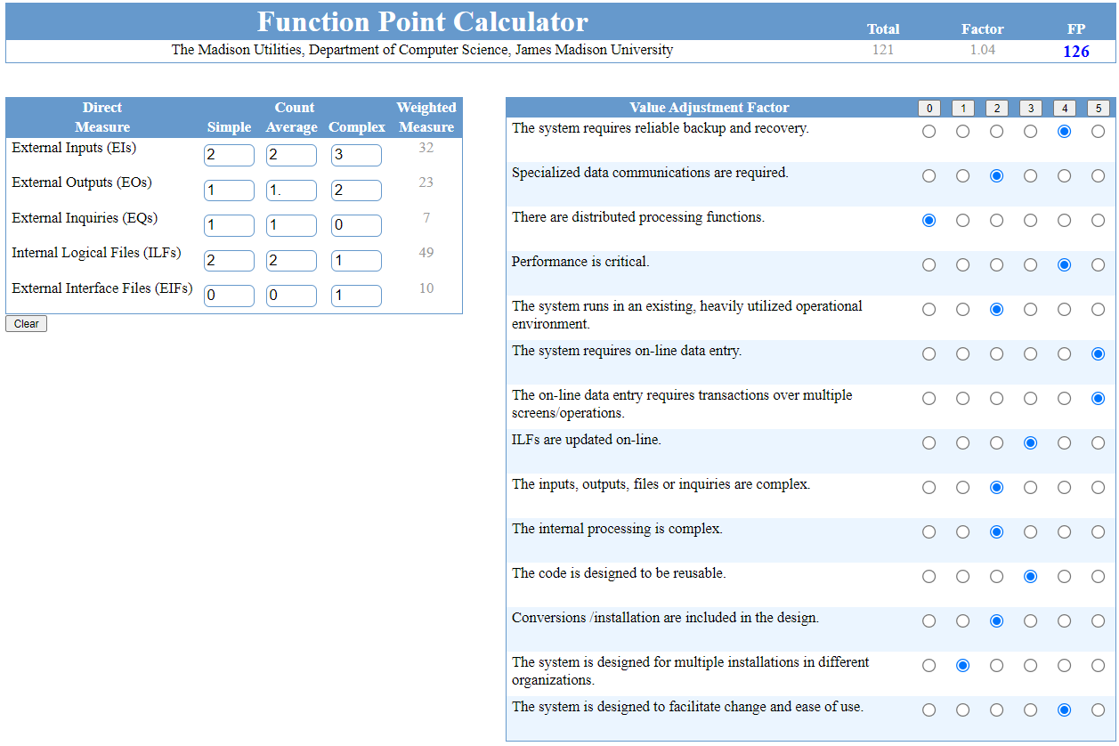

**Factors:**

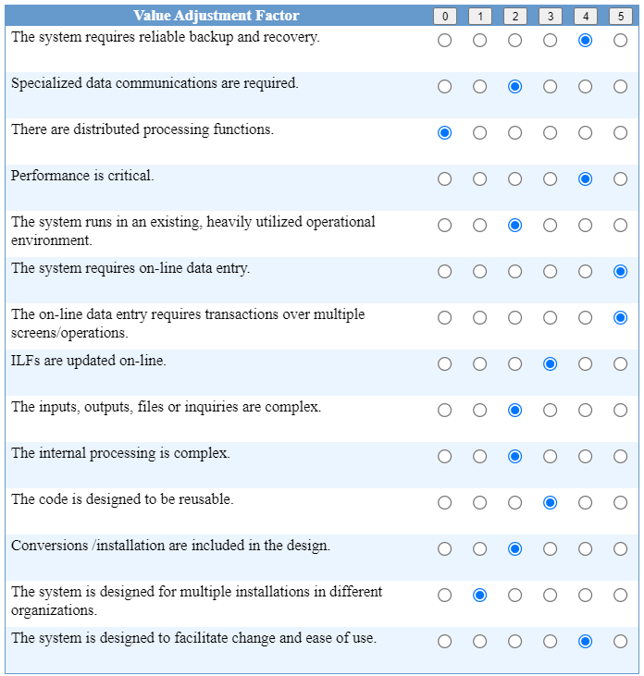

**Calculate Total FP**:

Total FP = 121

Factor = 1.04

Adjusted FP = 121 × 1.04 = 125.84 ≈ 126

**Person-Months Required**:

Using a realistic productivity rate 4 FP per person-month:

Persons per month = 126 / 4 = 32 persons / month

**Total Cost in INR**:

Assuming a cost per FP of ₹7000:

Total Cost in INR = 126 × 7000 = ₹8,82,000

### Final Estimate:

The FP estimate for this project is 126.

The project is estimated to require 32 persons per month.

The total cost is approximately ₹8,82,000.

**LOC:**

|  |  |  |  |  |
| --- | --- | --- | --- | --- |
| **Function** | **Optimistic LOC** | **Most Likely LOC** | **Pessimistic LOC** | **Estimated LOC** |
| User Registration | 900 | 1200 | 1300 | 1150 |
| Vehicle Listing | 1400 | 1650 | 1800 | 1650 |
| Booking Placement | 1500 | 1700 | 1800 | 1700 |
| Payment Processing | 1200 | 1500 | 1800 | 1600 |
| |  | | --- | | Booking Status |  |  | | --- | |  | | 800 | 1000 | 1200 | 1000 |
| |  | | --- | | Vehicle Search |  |  | | --- | |  | | 1300 | 1600 | 1700 | 1600 |
| |  | | --- | | Inventory Management |  |  | | --- | |  | | 850 | 1100 | 1300 | 1200 |
| |  | | --- | | User Profile Management |  |  | | --- | |  | | 700 | 900 | 1000 | 900 |
| |  | | --- | | Booking History Management |  |  | | --- | |  | | 1500 | 1600 | 1800 | 1600 |
| |  | | --- | | Payment Gateway Integration |  |  | | --- | |  | | 1700 | 2000 | 2300 | 2100 |
| Reports Generation | 1300 | 1500 | 1600 | 1500 |
| |  | | --- | | Vehicle Data Management | | 800 | 1000 | 1100 | 1000 |
| |  | | --- | | Booking Data Management |  |  | | --- | |  | | 900 | 1100 | 1250 | 1100 |
| |  | | --- | | User Data Management |  |  | | --- | |  | | 900 | 1150 | 1300 | 1200 |
| **TOTAL** |  |  |  | **19300** |

**Person-Months Required**:

Using a realistic productivity rate for systems of this type is 580 LOC/per-month.

Persons per-month = 19,300 / 580 = 33 persons-month

**Total Cost in INR**:

Assuming a cost per LOC of ₹40:

Total Cost in INR = 19,300 × 40 = ₹5,79,000

### Final Estimate:

The LOC estimate for this project is 19,300.

The project is estimated to require 33 persons per month.

The total cost is approximately ₹5,79,000.

**Conclusion:**

The experiment enhances our ability to estimate software size, cost, and resources, deepening their understanding of the software development process.

**Post Lab Descriptive Questions**

1. Explain COCOMO II model.

The COCOMO II (Constructive Cost Model II) is a software cost estimation model developed by Barry Boehm. It is an extension of the original COCOMO model and is designed to address the complexities of modern software development projects.

**Key Features of COCOMO II:**

1. **Three Sub-Models**:
   * **Application Composition Model**: Used for projects that rely heavily on reusable components or rapid application development environments.
   * **Early Design Model**: Applied during the early stages of a project when only high-level design information is available.
   * **Post-Architecture Model**: Used when detailed information about the system architecture and components is available.
2. **Scale Drivers and Cost Drivers**: COCOMO II incorporates scale drivers that affect the overall size and complexity of the project, and cost drivers that account for various attributes like product reliability, team experience, and tool support.
3. **Effort Estimation Formula**: COCOMO II provides an effort estimation formula that calculates the amount of person-months required to complete a project based on the size of the software (measured in KSLOC - Thousands of Source Lines of Code) and various project-specific factors.

COCOMO II is widely used for estimating the cost, effort, and schedule of software projects, helping project managers make informed decisions during the planning and development phases.